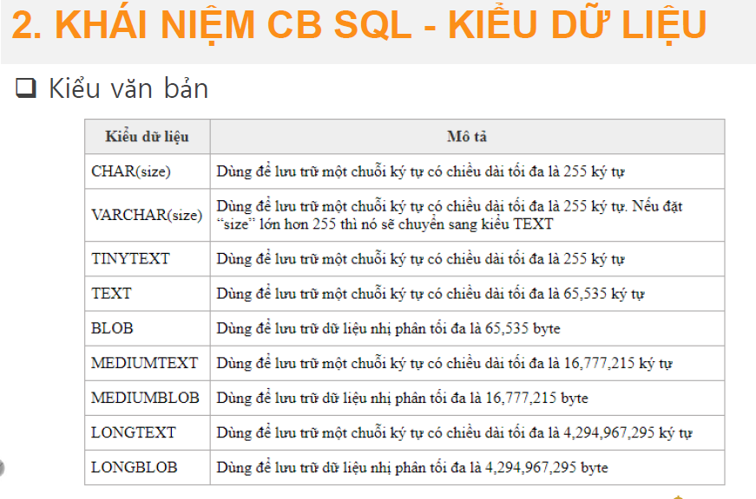

The data type for the gender column in the users table can be CHAR(1) or VARCHAR(1). This is because there are only two possible values for gender: male and female. Using a character data type with a length of 1 will allow us to store only one character for each gender.

Here is the updated SQL statement:

SQL

CREATE TABLE users(

id int auto_increment,

fullname varchar(100),

age int(200),

gender CHAR(1)

)

Use code with caution. [Learn more](https://bard.google.com/faq#coding)

content_copy

We can also use a VARCHAR(1) data type for the gender column. This is because the VARCHAR data type can store a variable-length string, up to the specified length. However, using a CHAR data type is more efficient, as it takes up less space in the database.